ASYNCHRONOUS CODE (Interview Important)
JAVASCRIPT(default) :
Is a synchronous (by default) : code executes one by one
Is a Single Threaded language : code executes on single thread but does not make you feel it is slow because we never use javascript engine alone but we always get javascript engine in any runtime environment (like browser , node.js)

BLOCKING CODE
Block the flow of program and read file sync
NON BLOCKING CODE
Do not Block the execution of program and read file Async
We use both type of code on depend on their use cases both are important in diff cases

How JavaScript handles asynchronous code behind the scenes. 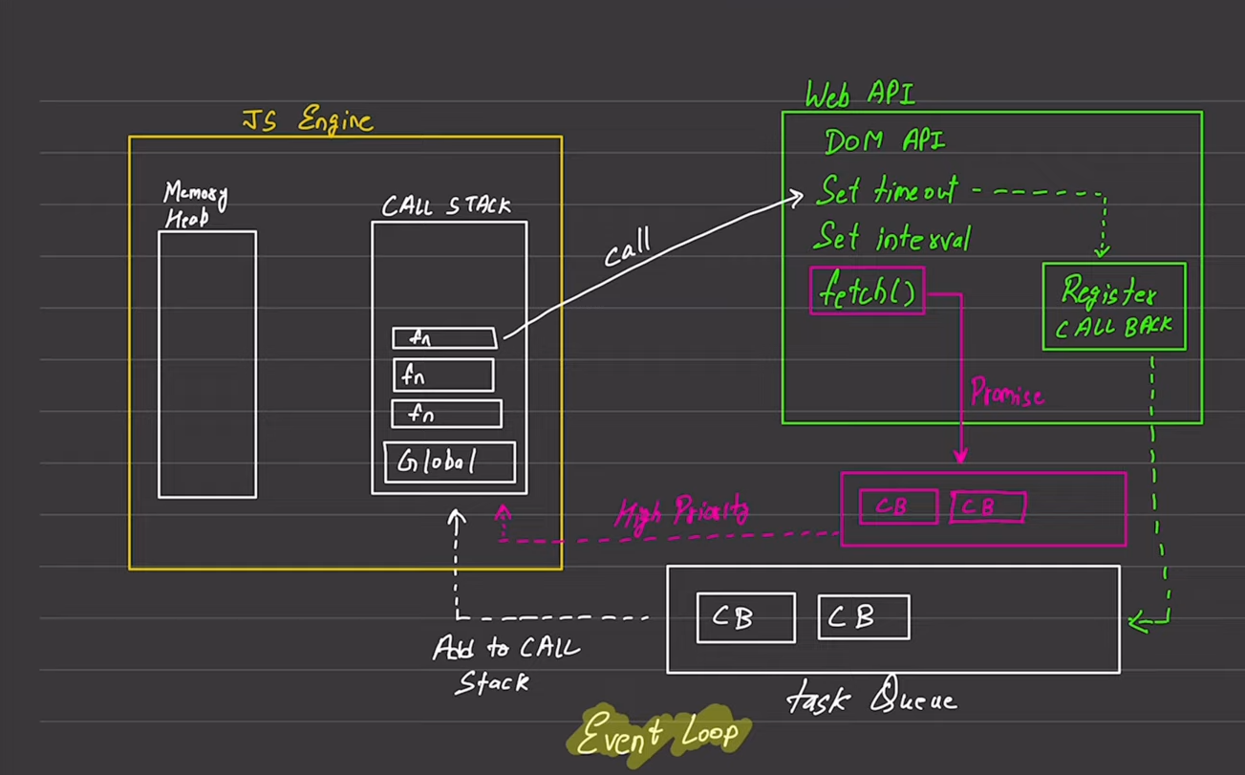

JS ENGINE (go through from global scopes / function scopes file for callstack):
Memory Heap — where variables and functions are stored in memory
Call Stack — where your code actually executes, one line at a time
WEB API OR NODE ENVIROMENT:
Web APIs are not part of JavaScript itself — they are extra tools provided by the browser(or nodejs-enviroment) to let JS do things it can't do alone.
When JS hits an async operation:
JS Code → "Hey Browser, please do this for me"
Browser → "Sure, I'll handle it. You keep running other code."
↓
Browser uses its own threads (C++ under the hood)
↓
When done → puts callback in Queue
↓
Event Loop → picks it up → back to JS
*) WEB APIS can handle many things like( setTimeout / setInterval , fetch() , DOM Events , Geolocation API , localStorage / sessionStorage , Notification API , MediaRecorder)
MICROTASK QUEUE (high priority):
• This holds callbacks from Promises (like .then()).
• These are high priority — they run before the Task Queue
* Event Loop picks it from the queue → runs on Call Stack
TASK QUEUE : (This make js that much fast)
• This holds callbacks from setTimeout, setInterval, etc.
• Lower priority than the Microtask Queue
EVENT LOOP :
The Event Loop constantly checks:
Is the Call Stack empty?
→ YES → First check Microtask Queue (Promises)
→ Then check Task Queue (setTimeout, etc.)
→ Push the next callback to the Call Stack
→ NO → Wait...
BASIC EXAMPLE OF WHOLE FLOW
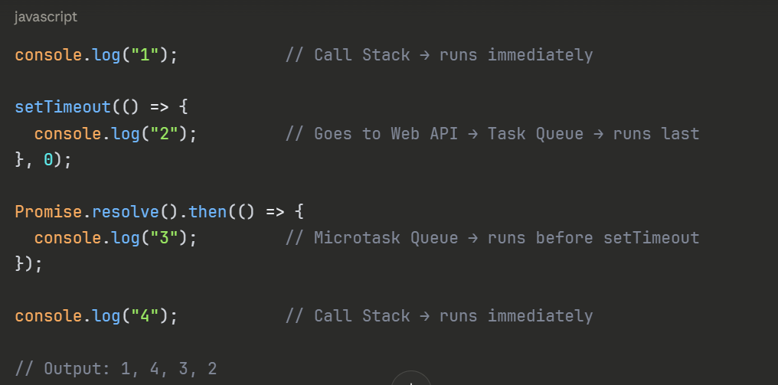
This is exactly why JS can handle network requests, timers, and events without freezing — even though it's single-threaded!
EXAMPLE (real life example of fetch() )
fetch("https://api.example.com/data")
.then(res => res.json())
.then(data => console.log(data))
1. JS calls fetch() → immediately handed to Browser's Network API
2. JS moves on, doesn't wait
3. Browser opens a network socket (separate C++ thread)
4. HTTP request is sent to server
5. Response arrives → Browser parses it
6. Browser creates a Promise resolution
7. .then() callback → goes to MICROTASK QUEUE
8. Event Loop picks it → runs on Call Stack

